**Azure Data Lake Store Gen2 vs Azure Blob storage**

Azure Data Lake Store Gen2 is a *superset* of Azure Blob storage capabilities. In the list below, some of the key differences between ADLS Gen2 and Blob storage are summarized.

* ADLS Gen2 supports ACL and POSIX permissions allowing for more granular access control compared to Blob storage.
* ADLS Gen2 introduces a hierarchical namespace. This is a true file system, unlike Blob Storage which has a flat namespace. This capability has a significant impact on performance, especially in big data analytics scenarios.
* ADLS Gen2 is an HDFS-compatible store. This means that Apache Hadoop services can use data stored in ADLS Gen2. Azure Blob storage is not Hadoop-compatible.
* ADLS Gen2 provides the same data redundancy and access tier offerings as Azure Blob storage.

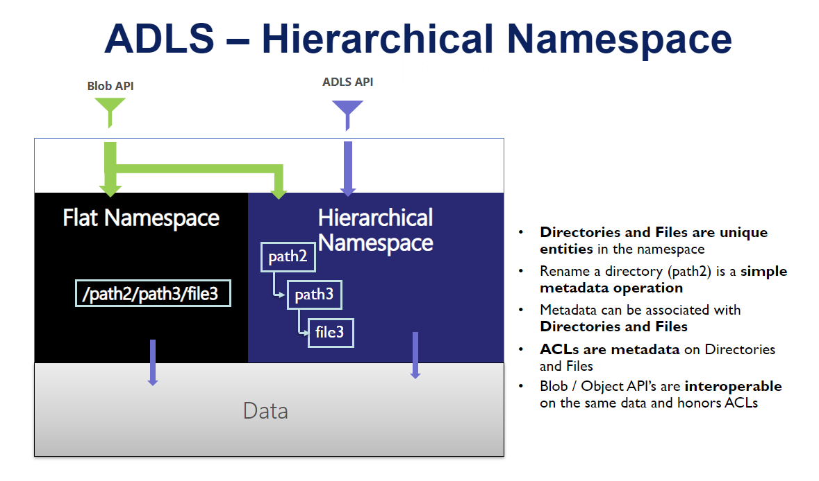

**Summary**

* **Structure**  
  Blob: Flat namespace object store.  
  ADLS: Hierarchical namespaces (much like a File System).
* **Purpose**  
  Blob: General purpose object store for a wide variety of storage scenarios, including big data analytics.  
  ADLS: Optimized storage for big data analytics workloads.
* **Performance**(Analytics Workload)  
  Blob: Good storage retrieval performance.  
  ADLS: Better storage retrieval performance.
* **Cost**  
  Blob: High cost for Analysis.  
  ADLS: Low cost for Analysis.